**How I made my advanced telegram bot using python?**

**Bot (Build-Operate-Transfer)** A bot short for robot**-** is a software program that performs automated, repetitive, pre-defined tasks.

Bot usually replaces human user behaviour Because they are automated, they operate much faster than humans users.

They carry out useful functions, such as customer service or indexing search engines, but they can also come in the form of malware – used to gain control over a computer.

Internet Bots can also be referred to as spiders, crawlers, or web bots.

**Telegram Bots-**



**Telegram Bots** are small software programs that can embedin Telegram Chats or public channels and perform a specific function or automated Telegram accounts you can chat with or add as friends to your chats, groups or channels.

Telegram Bots are third-party chat apps made with the Telegram Bot API. They can offer customized keyboards, produce cat memes on demand, or even accept payments and act as a digital storefront.

**Are Telegrams Bots Safe?**

While Telegram is known for end-to-end encryption, using MTProto researchers found that telegram bots rely on a less secure protocol called Transport Layer Security. Adding the telegram bots weakens the encryption, making it more susceptible to hackers.

**How Are Bots Different Than Humans?**

The following are differences between human members and bots in Telegram:

* For bots running in privacy mode, once added to a group they will not receive messages previously sent to the group.
* They have limited cloud storage therefore older processed messages are promptly removed by the server.
* Bots are not able to start conversations with people. They must be added to a group or a user must send them a message first.
* Their username will always end in “bot.”
* Their label displays as “bot” with no last seen time or online status information available.

**How to create and connect a Telegram Chatbot?**

**Chatbot**- It is an automated multifunctional assistant, that can receive send and send triggered messages, and with SendPulse (Multi-channel Marketing Automation Platform), your bot can save information as variables for future usage.

OR

A chatbot is an artificial intelligence (AI) application that can imitate a real conversation with a user in their natural language. Chatbots enable communication via text or audio on websites, messaging applications, mobile apps, or telephone.

**Benefits of a Chatbot-**

-Better customer engagement

-Cost savings

-Tracking gaining insights and consumer data

-Successful lead generation, qualification, and nurturing

-Easy operation in global markets

**Step by Step instruction to create your first chatbot for Telegram messenger-**

Open Telegram messenger, sign in to your account or create a new one.

Botfather- Botfather is the one bot for rule them to all. Use it to create new bots accounts and manage your existing bots.

Step 1- Enter @Botfather in the search tab and choose this bot.

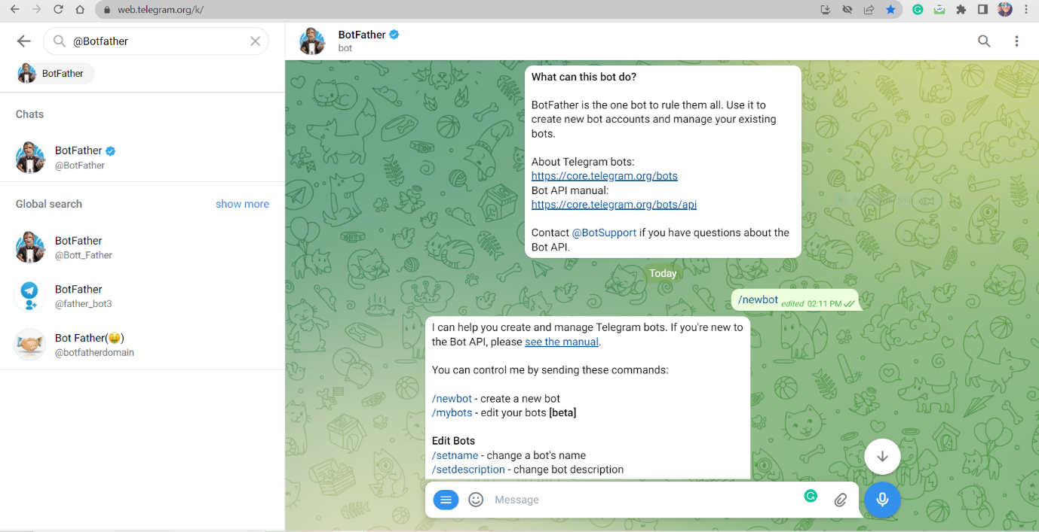

Note, Official Telegram bots have a blue checkmark beside their name.

Click “Start” to activate the Botfather bot.

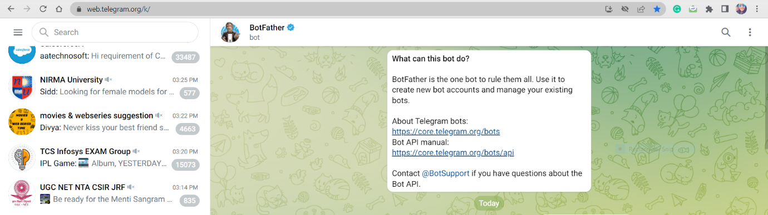

Then, you will receive a list of commands to manage bots.

Step 2- Choose or type the /newbot command and send it.

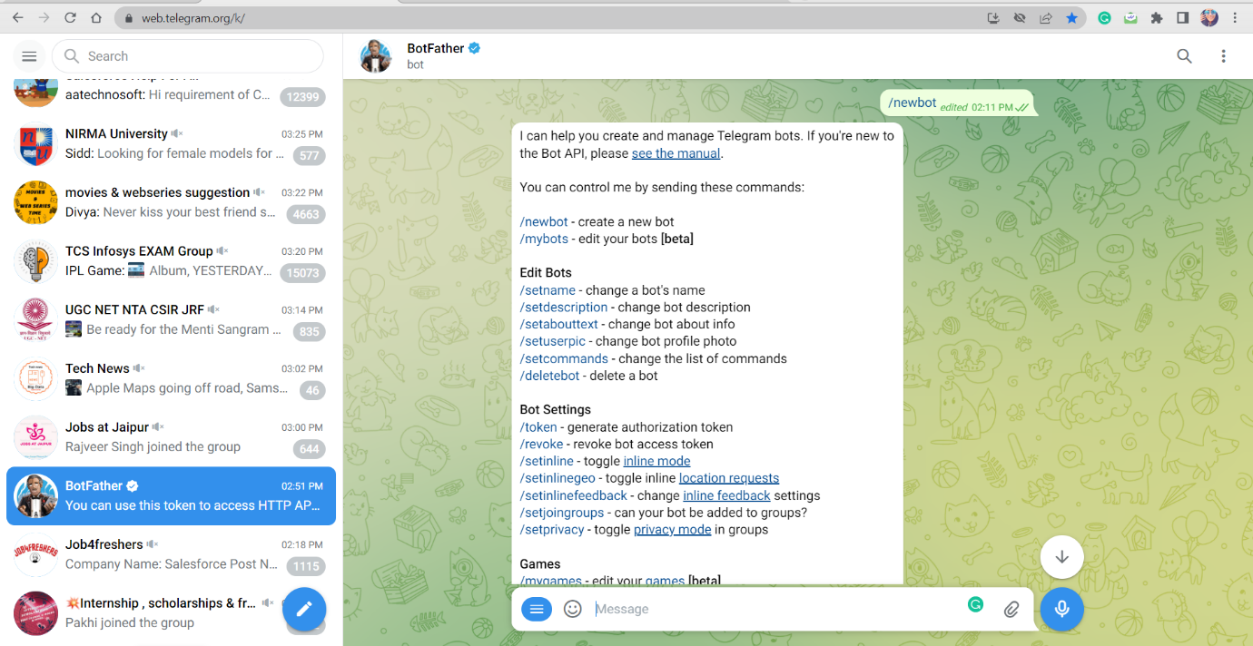

Step 3- Choose a name for your bot-your subscribers will see it in the conversation. And choose the username for the bot- the bot can be found in the username of the searches. The username must be unique and end with the word “bot”.

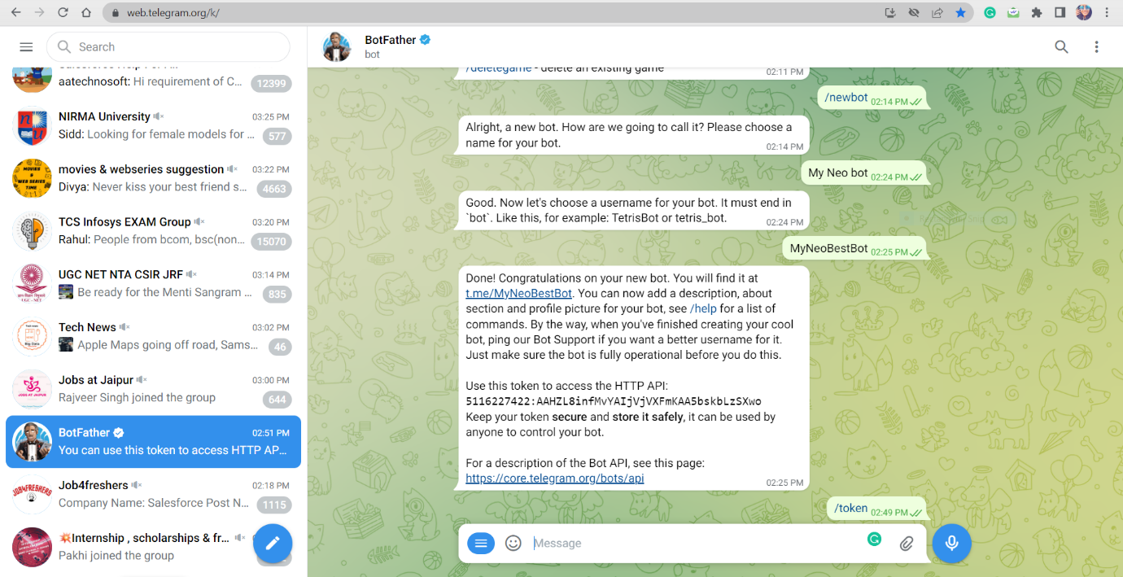

After you choose a suitable name for your bot-the bot is created. You will receive a message with a link to your bot t.me/<bot_username>, recommandations to set up a profile picture, description and list of commands to manage your new bot.

To connect a bot to SendPulse you need a token or key. Copy your token value and find more information about connecting your bot to SendPulse in the end.

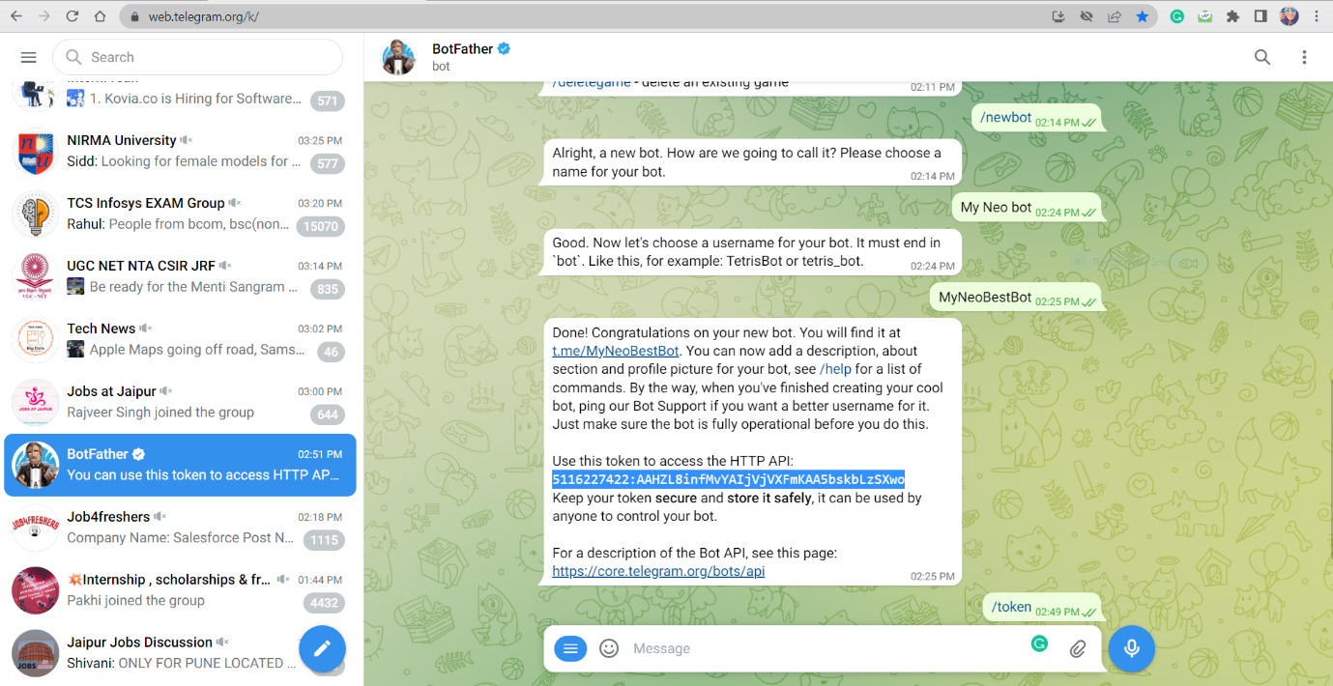

**How to Find a Token (Key) for an Existing Bot?**

**Step 1-** Go to the @Botfather bot and send the command /token.

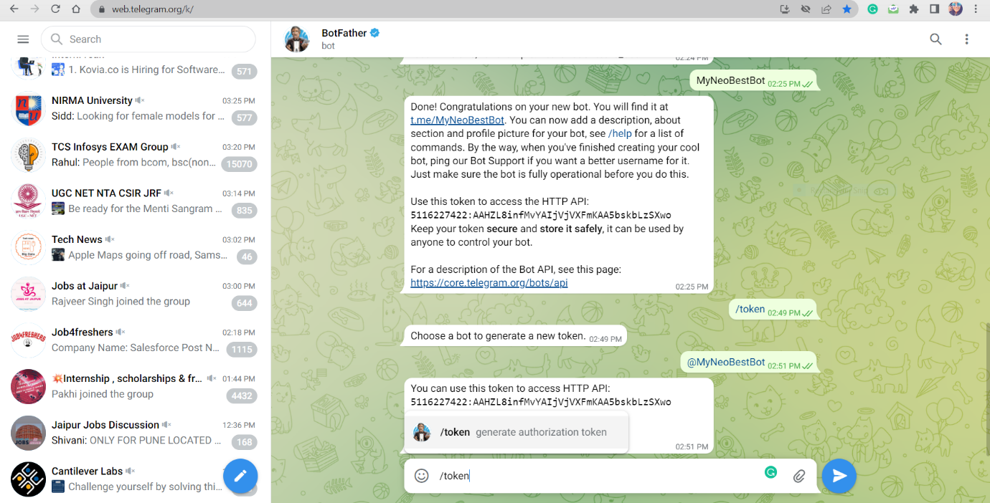

You will see buttons with any bots that you have created.

**Step 2-** Choose the one you need a token for so you can connect it with SendPulse. Choose a bot to generate a new token i.e., Type @MyNeoBestBot in the chat.

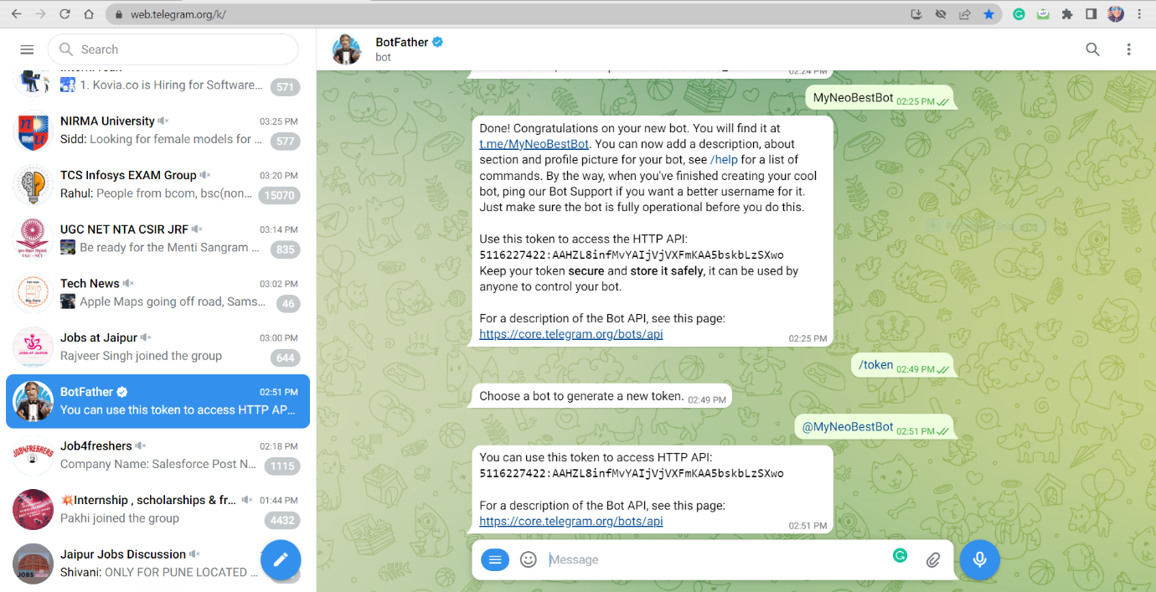

**Step 3-** Copy the Token Value.

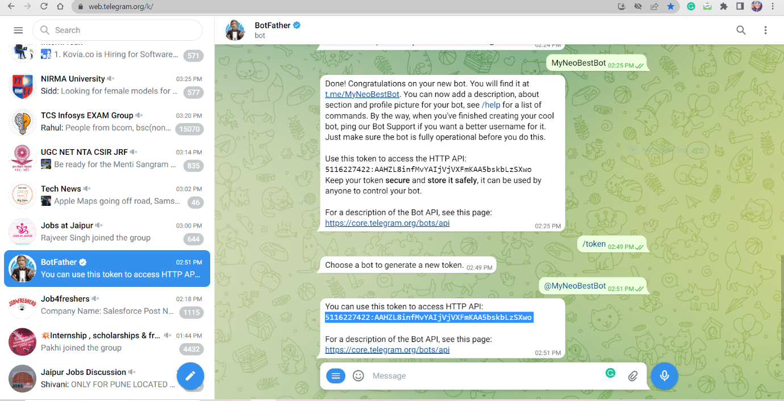

**How to Connect a Bot to SendPulse?**

**Step 1-** First make SendPulse Account by id and pswd.

**Step 2-** Go to chatbots section in your sendpulse account. If it’s first time vising this page and have not connected any chatbots- click the “Connect Channels” buttons.

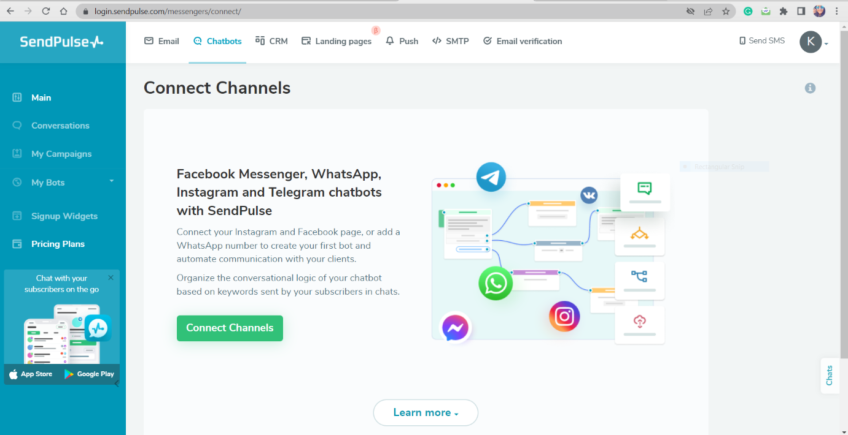

**Step 3**- Choose Telegram button

**Step 4-** Enter your token from the NeoBot and click “connect”.

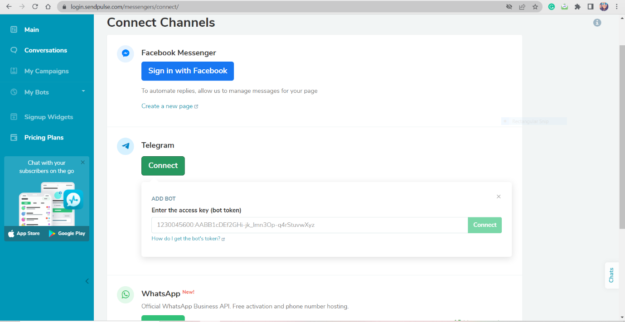

In the Next window click the “Subscribe button.

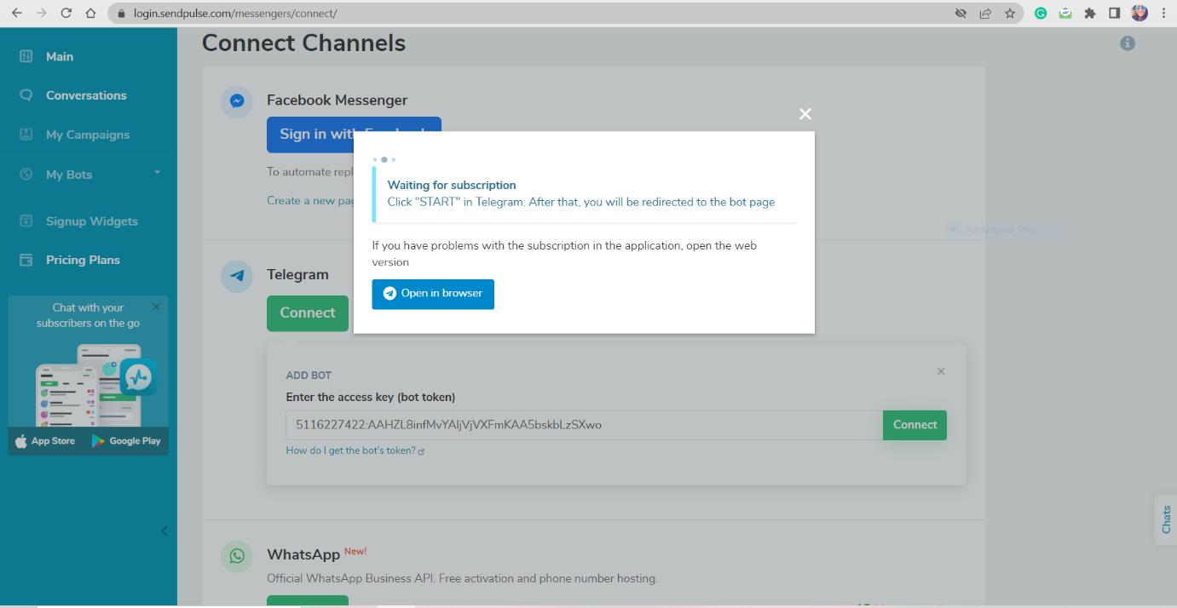

You will be redirected to the [Telegram app](https://telegram.org/apps), click on the “Start” button and you will be subscribed to your bot.

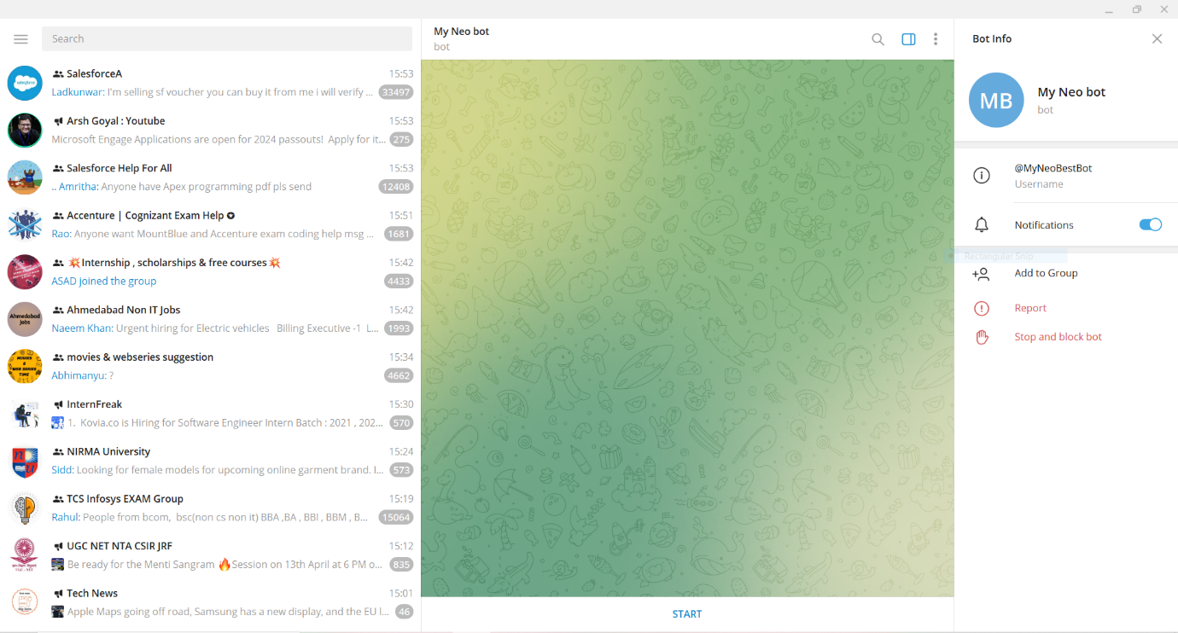

Congratulations! You have successfully added your chatbot to SendPulse.

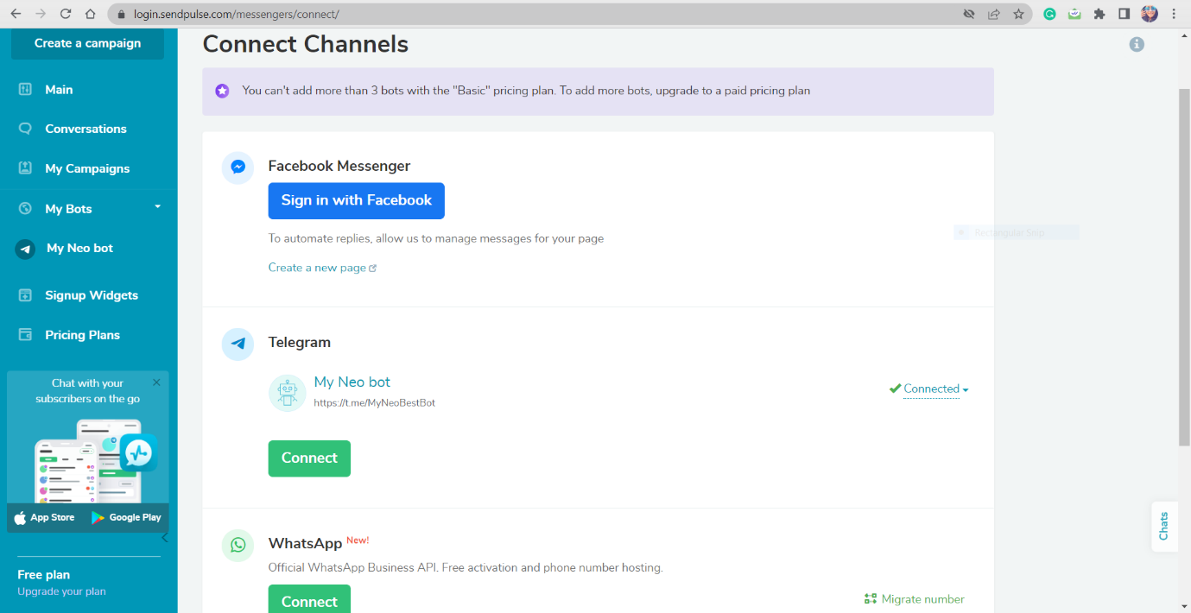

You can use this token to access HTTP API: 5116227422:AAHZL8infMvYAIjVjVXFmKAA5bskbLzSXwo

Installation-

CMD-

pip install python-telegram-bot

import telebot**,**sys  
key = "5131778092:AAHTuHEAdFO3iUolAroWtK0Qj_xGz5Qu-c8"  
  
bot = telebot.TeleBot(key)  
  
  
# start  
@bot.message_handler(commands=['start'])  
def start(message):  
 name = message.chat.first_name  
 bot.send_message(message.chat.id**,** "Hello " + name)  
 bot.send_message(message.chat.id**,**"Select /start or select /register")  
  
# register  
@bot.message_handler(commands=['register'])  
def register(message):  
 name = message.chat.first_name  
 msg=bot.send_message(message.chat.id**,** "Enter our pin code ")  
 bot.register._next_step_handler(msg**,**pin_code_step)  
  
def pin_code_step(message):  
 pin=message.text  
 if pin in ['000000'**,** '111111'] or not len(pin)==**6**:  
 bot.send_message(message.chat.id**,** "Pin is incorrect")  
 return  
 else:  
 bot.send_message(message.chat.id**,** "Registered..!")  
  
  
print("Telegram Bot started...")  
bot.polling()

from telegram.ext.updater import Updater  
from telegram.update import Update  
from telegram.ext.callbackcontext import CallbackContext  
from telegram.ext.commandhandler import CommandHandler  
from telegram.ext.messagehandler import MessageHandler  
from telegram.ext.filters import Filters  
  
updater = Updater("5131778092:AAHTuHEAdFO3iUolAroWtK0Qj_xGz5Qu-c8"**,** use_context=True)  
  
  
def start(update: Update**,** context: CallbackContext):  
 update.message.reply_text("Hello mam, Welcome to the Bot.Please write\/help to see the commands available.")  
  
  
def help(update: Update**,** context: CallbackContext):  
 update.message.reply_text("""Available Commands :-  
 /youtube - To get the youtube URL  
 /linkedin - To get the LinkedIn profile URL  
 /gmail - To get gmail URL  
 /geeks - To get the GeeksforGeeks URL""")  
  
  
def gmail_url(update: Update**,** context: CallbackContext):  
 update.message.reply_text("Your gmail link =>\https://mail.google.com/mail/u/1/#inbox")  
  
  
def youtube_url(update: Update**,** context: CallbackContext):  
 update.message.reply_text("Youtube Link =>\https://www.youtube.com/")  
  
  
def linkedIn_url(update: Update**,** context: CallbackContext):  
 update.message.reply_text("LinkedIn URL => \https://www.linkedin.com/in/kajolmalhotra")  
  
  
def geeks_url(update: Update**,** context: CallbackContext):  
 update.message.reply_text("GeeksforGeeks URL => https://www.geeksforgeeks.org/")  
  
  
def unknown(update: Update**,** context: CallbackContext):  
 update.message.reply_text("Sorry '%s' is not a valid command" % update.message.text)  
  
  
def unknown_text(update: Update**,** context: CallbackContext):  
 update.message.reply_text("Sorry I can't recognize you , you said '%s'" % update.message.text)  
  
  
updater.dispatcher.add_handler(CommandHandler('start'**,** start))  
updater.dispatcher.add_handler(CommandHandler('youtube'**,** youtube_url))  
updater.dispatcher.add_handler(CommandHandler('help'**,** help))  
updater.dispatcher.add_handler(CommandHandler('linkedin'**,** linkedIn_url))  
updater.dispatcher.add_handler(CommandHandler('gmail'**,** gmail_url))  
updater.dispatcher.add_handler(CommandHandler('geeks'**,** geeks_url))  
updater.dispatcher.add_handler(MessageHandler(Filters.text**,** unknown))  
updater.dispatcher.add_handler(MessageHandler(Filters.command**,** unknown)) # Filters out unknown commands  
  
# Filters out unknown messages.  
updater.dispatcher.add_handler(MessageHandler(Filters.text**,** unknown_text))  
  
def shutdown():  
 updater.stop()  
 updater.is_idle = False  
def stop(bot**,** update):  
 threading.Thread(target=shutdown).start()  
def main():  
 dp = updater.dispatcher  
 dp.add_handler(CommandHandler('stop'**,** stop))  
 updater.bot.send_message(chat_id=settings.my_id**,** text="Here is a message from the bot")  
 updater.start_polling()  
 print("Bot is waiting for user input")  
 updater.idle()  
 print("Last row is reached")  
updater.start_polling()  
updater.idle()  
updater.stop()

**Developing a Money-Making Telegram Bot on Python-**

## Stage 1 — the strategy-

1) Build a simple Telegram bot. and I will check the complexity and timescale of the problem.

2) Research and idea generation. And also I have gathered it has plenty of bots and it would take some research and understanding to figure out what bot to build out.

3) Development.

4) Launching the bot and marketing it. It is one job to develop the bot, but marketing also needs to paid attention to it, has it very unlikely to actually sign up.

5) Waiting for the first profit of bot to achieve through this.

## Stage 2- How the Telegram bot works-

In short, there is a certain command how to create for the bot. the bot performs whatever the command asks for the request.

1. Get the API token by finding the Botfather bot- the official bot telegram to create its bots
2. Then, we have to import the pyTelegramBot API.
3. Next, we will find place to secure our API token. API token can be store in secret section. The key here referred to as a Token, while the value is actual value of the token

**Coin Gecko Website** and it will show us those prices in our telegram. We will create a bot that will fetch those prices for you different cryptocurrencies and show those prices in that bot

telebot is a library----

**\*\*\*\*\*# Crypto API – coin gecko**

**# Telegram API – telebot**

**# Write\*\*\*\*\***

1. Either send row request with python.
2. Install gecko API its client for python.